**Bangalore Institute of Technology**

**K.R. ROAD, BENGALURU-560004.**

**Department of Computer Science and Engineering**

**DBMS Mini Project Synopsis**

**College Event Management System**

|  |  |  |  |  |
| --- | --- | --- | --- | --- |
| **USN** | **NAME** | **BATCH** | **PHONE NO** | **E-MAIL** |
| 1BI19CS172 | Manohar Raj | C3 | 7483090054 | [manoharraj368@gmail.com](mailto:manoharraj368@gmail.com) |
| 1BI19CS182 | Vedant Badiger | C4 | 9008410945 | vedantbadiger4132@gmail.com |

Problem Domain: Education

Lab In-Charges:

20-12-2021

**2021-2022**

**For office use only:**

**Accepted :**

**To be modified :**

**Rejected :**

**Signature of the Lab In-Charges**

# Index

|  |  |  |
| --- | --- | --- |
| **SL NO.** | **CONTENT** | **PAGE NO.** |
| 01 | Title | 03 |
| 02 | Introduction | 03 |
| 03 | Problem Statement | 04 |
| 04 | Front-end and Back-end details | 04 |
| 05 | ER Diagram | 05 |
| 06 | ER to Relational Mapping | 06 |
| 07 | Modules | 07 |
| 08 | Applications | 07 |

# Title

College Event Management System

# Introduction

The Event Management System is a system used to manage, event data , club data , department data and participant data.

The main purpose of this system is to convert the monotonous process of event handling system into an effective computerised system.

Drawbacks of the conventional result management system:-

In conventional event management system, co-ordinators spend a lot of time in writing down all the details of participants. This Conventional approach includes maintainance of large records of events/participants, which includes manual procedures like pen-paper work which leads to problems like:-

* Slow Processing
* Participants have to always meet the co-ordinators in order to get to know/enroll themselves in an event.
* It has been quite a difficult task for the co-ordinators to maintain the records of their participants in an effective manner.

# Problem Statement

To Develop a system that will manage:

* Information about various Participants of an event
* Information about events offered by various Departments/Clubs/Companies.
* Generation of an enrollment of an individual.

# Front-end and Back-end tool details

Front-end components:-

* Hyper Text Markup Language [HTML] 5
* Cascading Style Sheets [CSS] 3
* BootStrap 5

Back-end components:-

* Java[Jakarta Service Packages(JSP)[formerly Java Server Pages]]
* MySQL

# Entity Relationship [ER] Diagram

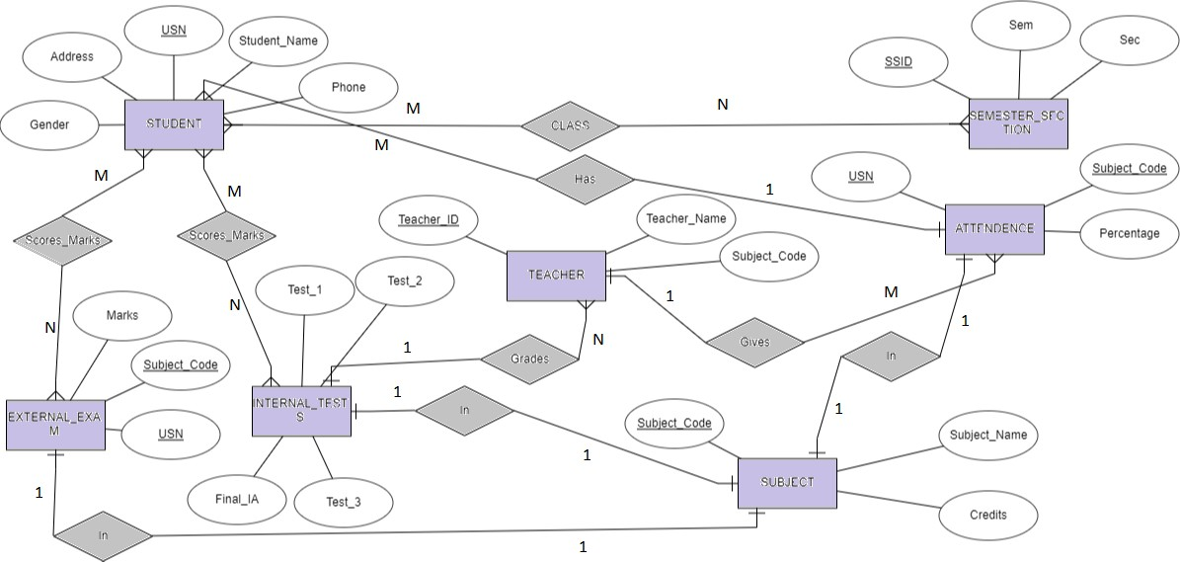

# ER To Relational Mapping

Category Table

|  |  |
| --- | --- |
| Category__id | Category |

Department Table

|  |  |  |  |
| --- | --- | --- | --- |
| Dept_no | Dept_Name | HOD | Contact |

Club Table

|  |  |  |  |
| --- | --- | --- | --- |
| Club_no | Club_Name | President | Contact |

|  |  |  |  |  |  |  |
| --- | --- | --- | --- | --- | --- | --- |
| Event_id | Event_name | Date | Time | Duration | Location | Amount |

Event Table

|  |  |  |  |  |  |  |  |
| --- | --- | --- | --- | --- | --- | --- | --- |
| Event_id | Name | USN | Sem | Branch | Phone | E-mail | Payment_stat |

Participants Table

Department event

|  |  |  |
| --- | --- | --- |
| Department_id | Category_id | Event_id |

Club event

|  |  |  |
| --- | --- | --- |
| Club_id | Category_id | Event_id |

Company Event

|  |  |
| --- | --- |
| Event_id | Company_name |

# Modules

1. Participant module:

In this module, the Participants will enter their details such as USN, Name, Branch, Contact details and pay the prescribed amount (for paid events) and will get themselves enrolled for a particular event.

1. Host module:

In this module, a Host creates a new unique id for their event, enters the details of the event such as Event name, date, time, duration, location and amount to be paid. By doing this the participants will be able to get to know about the event and it’s details.

# Applications

Overcomes the drawbacks of Conventional Event Management System such as no pen-paper work is need to be carried out. Processing will be faster. Also:

* + Participants can easily enroll/disenroll themselves in any event conducted in college.
  + Hosts can easily add and update the details of any event.
  + The data can be stored for a longer time without worrying about the damage caused by any kind of technical prospects.